Database Design Guide

This guide will help the student to create a database on the Wakefit It will help to manage the below functionalities.

1.Product

2.Product_Category

3.Customer

4.Orders

5.Order_item

6.State

7.country

8.payment

9.feedback

10. address

We will use MySQL as the DBMS to create the database and its related operations.

# 1. Introduction to MySQL

MySQL is an open-source relational database management system (RDBMS) that uses structured query language (SQL) to manage and manipulate data in a database. It is widely used for various applications, from small web applications to large enterprise systems.

MySQL's key features include:

* Scalability: Capable of handling large amounts of data and concurrent connections.
* Flexibility: Supports various data types and storage engines.
* Performance: Optimized for speed and efficiency.
* Reliability: Known for its stability and robustness.

commonly used in database design to help developers and stakeholders understand the structure and relationships within a database.

# Identify Entities

* Start by identifying the main entities in your system. These are the objects or concepts about which you want to store data.
* Each entity should correspond to a table in your database.

# Define Attributes

* For each entity, list the attributes (properties or fields) that describe it.
* These attributes will become columns in the corresponding database table.

# Identify Relationships

* Determine how entities are related to each other. There are three types of relationships: one-to-one (1:1), one-to-many (1:N), and many-to-many (N:M).
* Represent these relationships using lines connecting the entities.

Let’s see a few examples of relationships:

# One to One

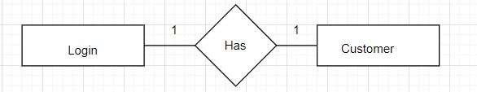

# One to Many

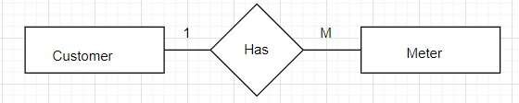

# Many to One

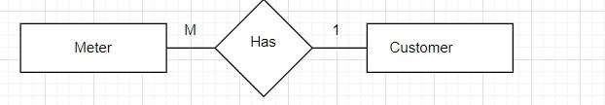

# Many to One

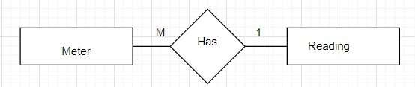

# Many to Many

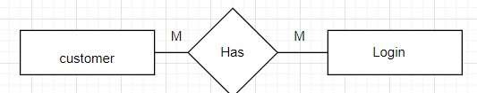

# Cardinality Notation

Cardinality represents the number of times an entity of an entity set participates in a relationship set. Or we can say that the cardinality of a relationship is the number of tuples (rows) in a relationship.

* Use notation (such as Crow's Foot Notation or Chen Notation) to indicate the cardinality of each relationship.
* Cardinality describes how many instances of one entity are related to how many instances of another entity.
* Common notations include:
* One (1)
* Zero or one (0..1)
* Many (N)
* Zero or many (0..N)

Optional:

# Add Attributes and Constraints

• Include additional information in your ERD, such as primary keys, foreign keys, and constraints (e.g., unique constraints).

# Create the Diagram

* Use specialized diagramming software or tools (e.g., Lucidchart, draw.io, or even pen and paper) to create your ERD.

Refine and Review:

* Review your ERD with stakeholders and team members to ensure it accurately represents the data model and relationships. Make any necessary refinements.

Let’s identify the entities of the WakeFit

1.Product

2.Product_Category

3.Customer

4.Orders

5.Order_item

6.State

7.country

8.payment

9.feedback

10. address

11.login

Table Structure

# 1.Product

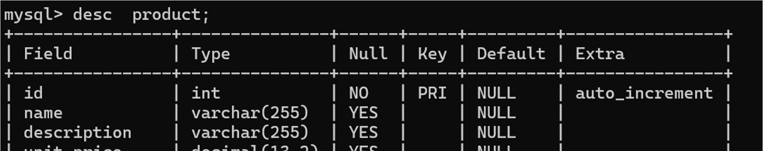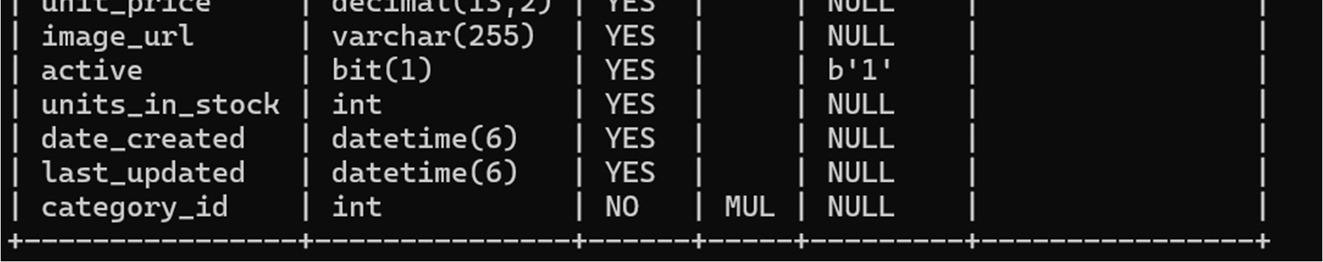

# 2.Product_Category

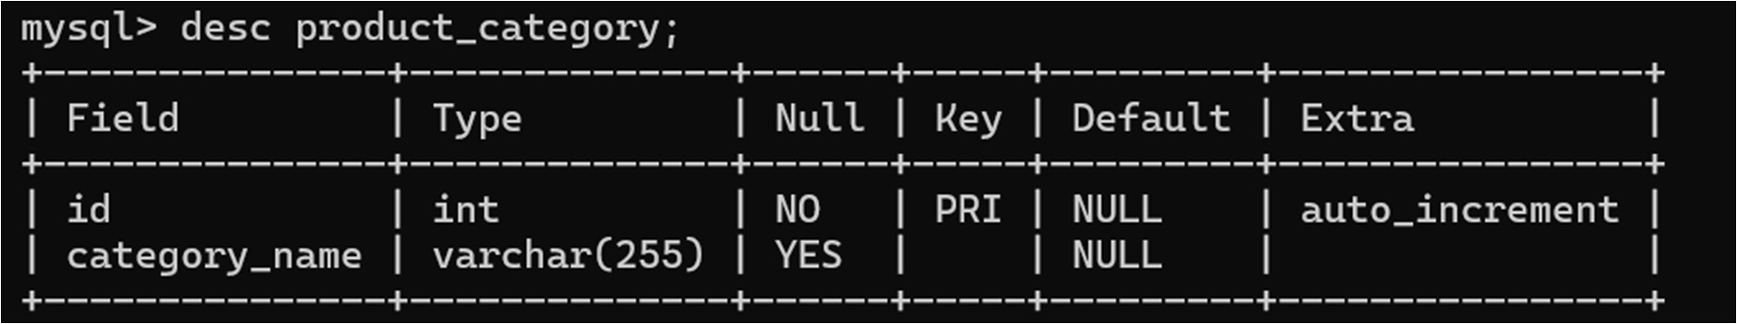

# 3.Customer

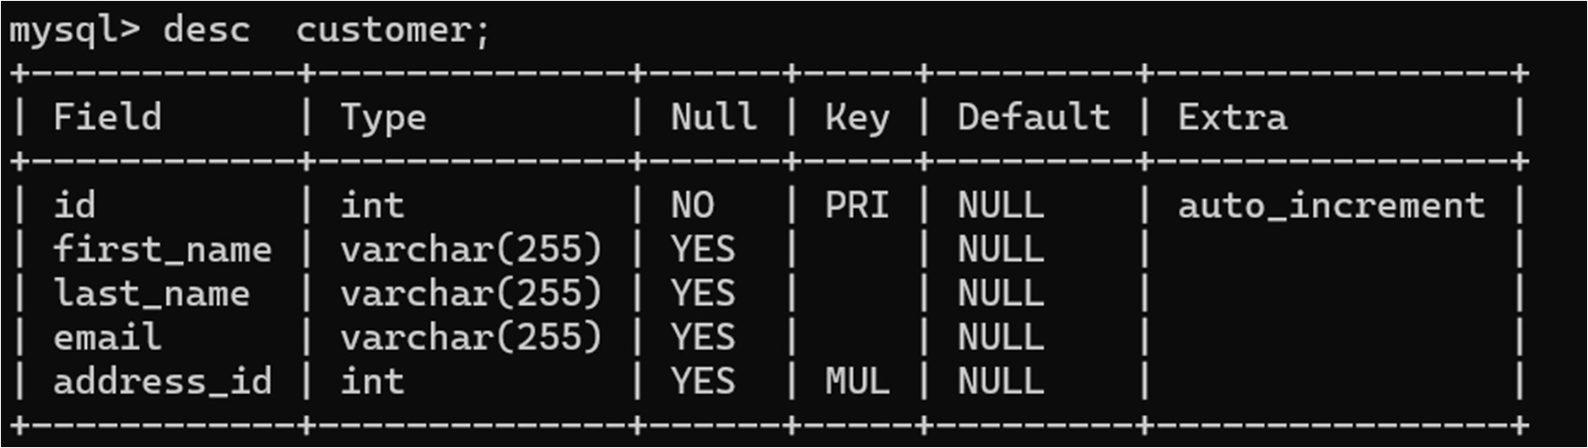

# 4.Orders

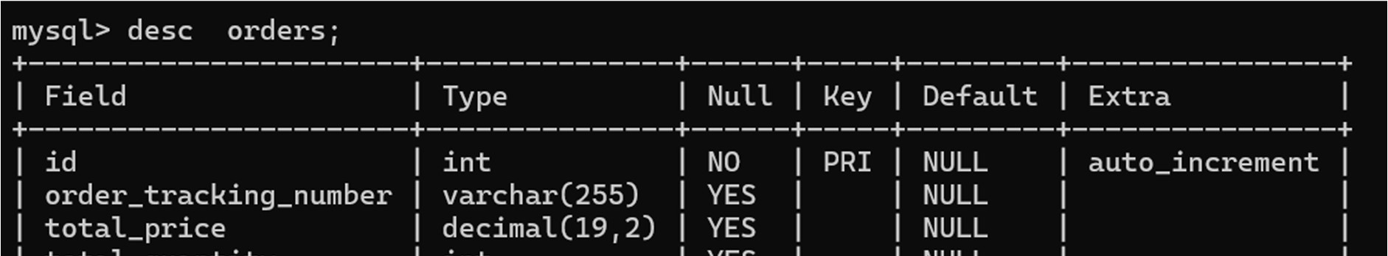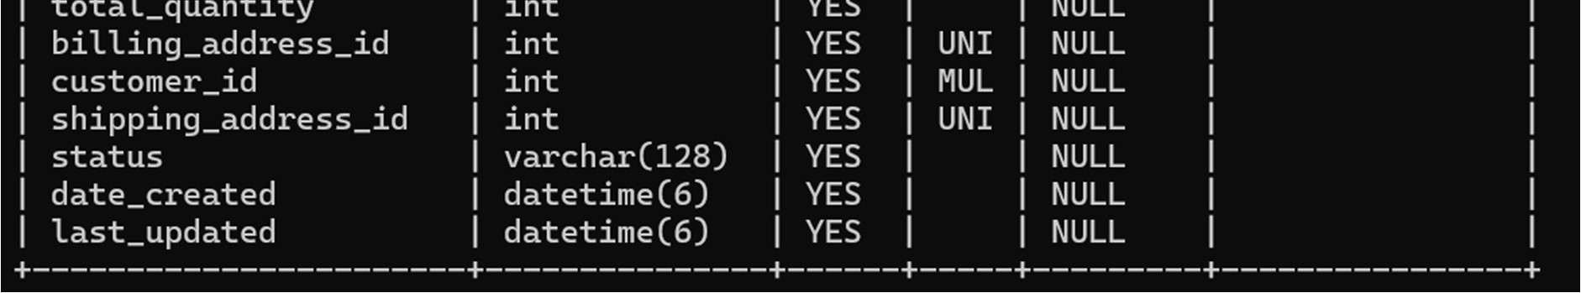

# 5.Order_item

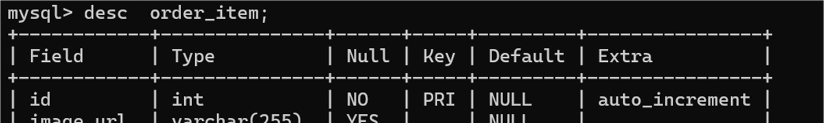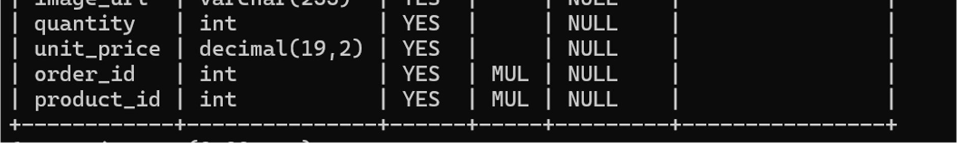

# 6.country

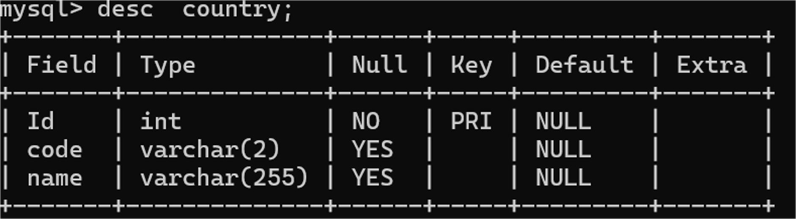

# 7.state

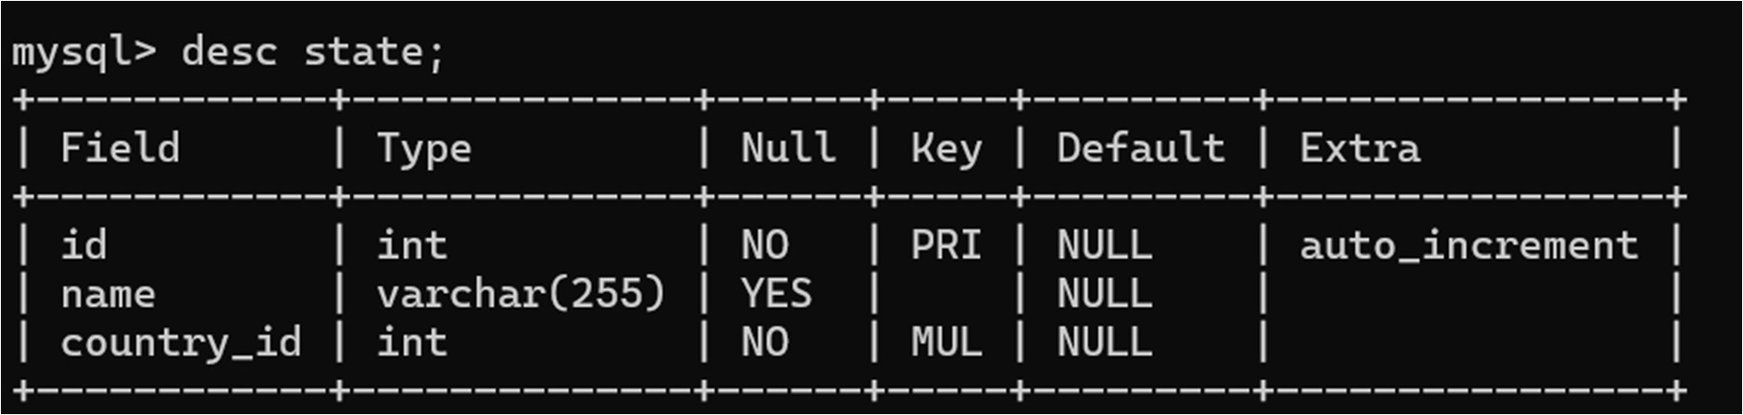

# 8.payment

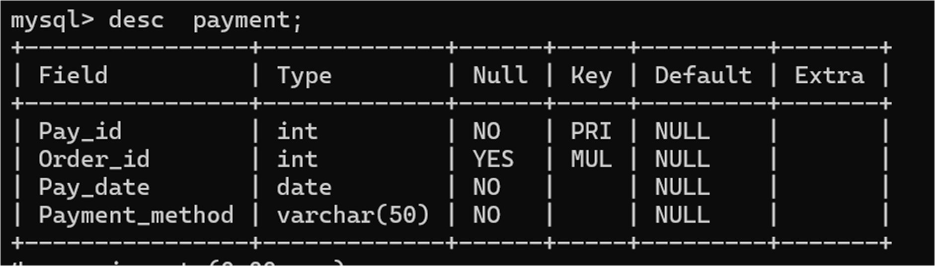

# 9.feedback

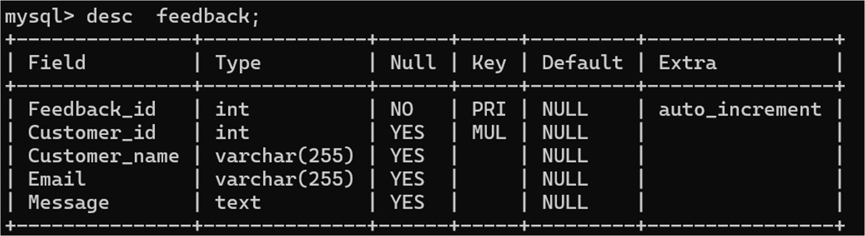

# 10. address

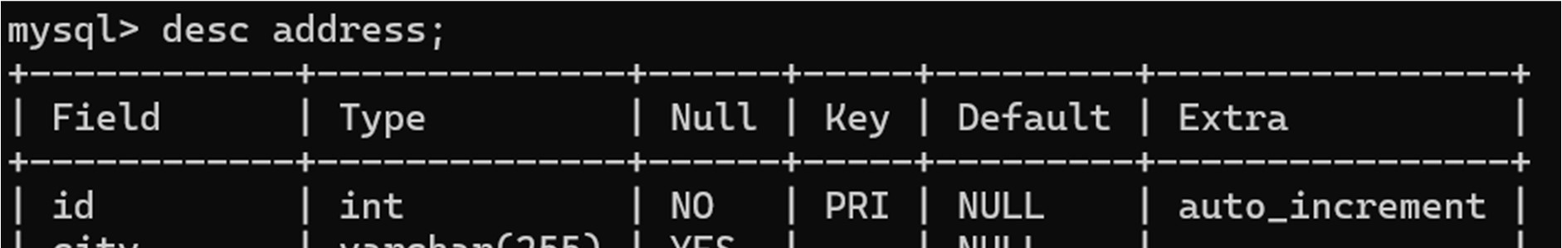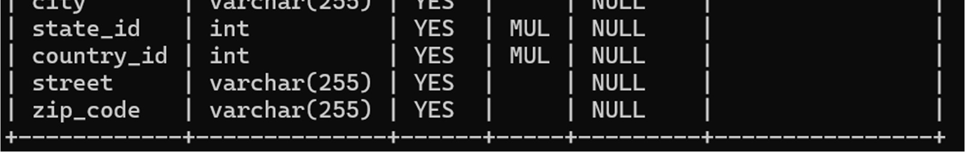

11.login

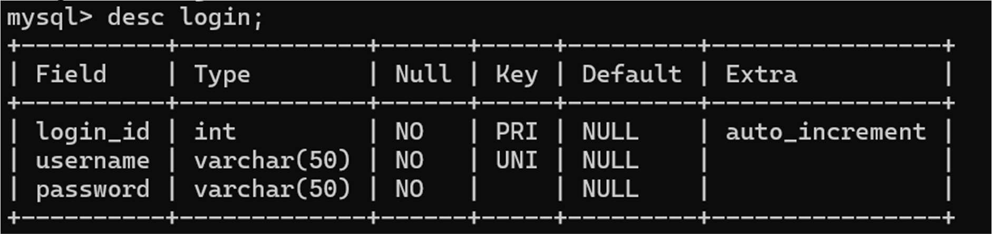

Now, let’s create the ER diagram to visually represent the entities and relationships.

# ERD Diagram

In this ERD:

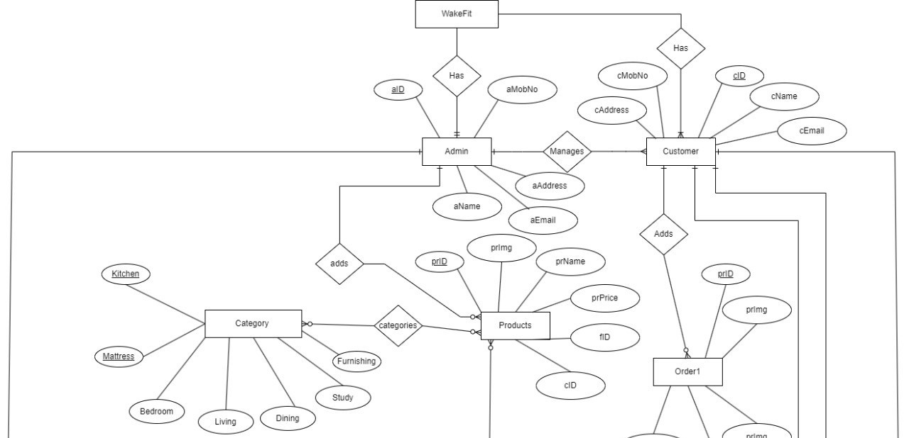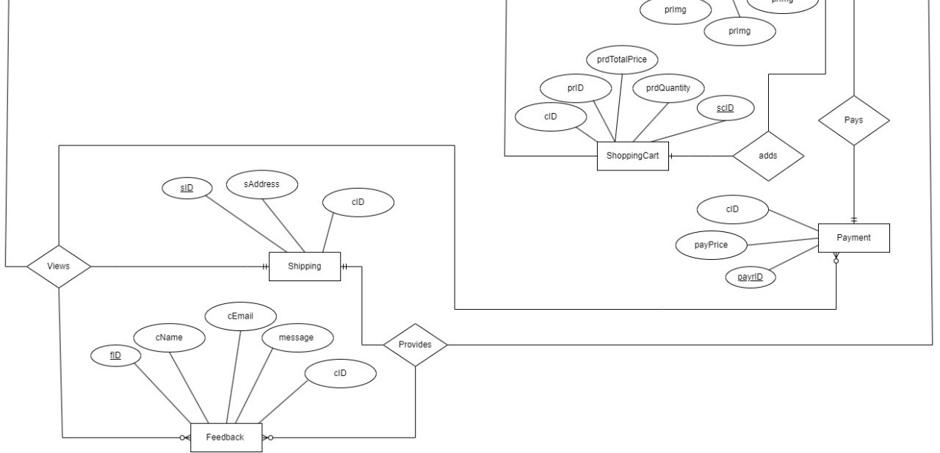

The Login table stores login credentials with a unique username and a corresponding password for authentication purposes.

The Customer table contains information about customers, including their names, email addresses, and foreign key reference to the address table for their location details.

The Product table holds details about various products available in the system, such as their name, description, price, availability, and category. It also includes foreign key references to the product_category table for categorization.

Product_Category table categorizes products into different categories, facilitating organization and navigation for users.

Orders table manages information related to orders, including order tracking numbers, total prices, quantities, and status. It also maintains foreign key references to the customer table for customer details and to the address table for billing and shipping addresses.

Order_Item table represents individual items within orders, including details such as image URLs, quantities, and unit prices. It also includes foreign key references to the orders and product tables for order and product identification.

Country table contains information about countries, including their unique identifiers, ISO codes, and names.

State table stores details about states or regions within countries, with references to the country table to establish relationships between states and countries.

Payment table records payment details for orders, including payment IDs, associated order IDs, payment dates, and payment methods, with a foreign key reference to the orders table for order identification.

Feedback table captures feedback provided by customers, including customer IDs, names, email addresses, and feedback messages, with a foreign key reference to the customer table for customer identification.

Address table stores address information, including city, country, state, street, and zip code details, with a unique identifier for each address entry.

# 4. Creating a Database

Using MySQL server, create a new database for your student management system. You can do this with SQL commands or through the graphical interface.

CREATE DATABASE wakefit;

# 5. Using a Database

Before performing any operations on a database, you need to select it using the USE statement:

USE wakefit;

# 6. Creating the tables for each entity

USE wakefit;

1.Login CREATE TABLE Login ( login_id INT AUTO_INCREMENT PRIMARY KEY, username VARCHAR(50) UNIQUE NOT NULL, password VARCHAR(50) NOT NULL

);

2.Customer

CREATE TABLE customer ( id INT NOT NULL AUTO_INCREMENT, first_name VARCHAR(255) DEFAULT NULL, last_name VARCHAR(255) DEFAULT NULL, email VARCHAR(255) DEFAULT NULL, address_id INT,

PRIMARY KEY (id),

FOREIGN KEY (address_id) REFERENCES address(id)

) AUTO_INCREMENT=1;

# 3.Product

CREATE TABLE product ( id INT(20) NOT NULL AUTO_INCREMENT, name VARCHAR(255) DEFAULT NULL, description VARCHAR(255) DEFAULT NULL, unit_price DECIMAL(13,2) DEFAULT NULL, image_url VARCHAR(255) DEFAULT NULL, active BIT DEFAULT 1, units_in_stock INT(11) DEFAULT NULL, date_created DATETIME(6) DEFAULT NULL, last_updated DATETIME(6) DEFAULT NULL, category_id INT(20) NOT NULL,

PRIMARY KEY ( id),

KEY fk_category ( category_id),

CONSTRAINT fk_category FOREIGN KEY ( category_id) REFERENCES product_category (id)

) AUTO_INCREMENT = 1;

# 4.Product_Category

CREATE TABLE product_category ( id INT(20) NOT NULL AUTO_INCREMENT, category_name VARCHAR(255) NULL DEFAULT NULL,

PRIMARY KEY (id)) AUTO_INCREMENT = 1;

# 5.Orders

CREATE TABLE orders( id int NOT NULL AUTO_INCREMENT, order_tracking_number varchar(255) DEFAULT NULL, total_price decimal(19,2) DEFAULT NULL, total_quantity int DEFAULT NULL, billing_address_id int DEFAULT NULL, customer_id int DEFAULT NULL, shipping_address_id int DEFAULT NULL, status varchar(128) DEFAULT NULL, date_created datetime(6) DEFAULT NULL, last_updated datetime(6) DEFAULT NULL,

PRIMARY KEY (id),

UNIQUE KEY UK_billing_address_id (billing_address_id),

UNIQUE KEY UK_shipping_address_id (shipping_address_id),

KEY K_customer_id (customer_id),

CONSTRAINT FK_customer_id FOREIGN KEY (customer_id) REFERENCES customer (id),

CONSTRAINT FK_billing_address_id FOREIGN KEY (billing_address_id) REFERENCES address (id),

CONSTRAINT FK_shipping_address_id FOREIGN KEY (shipping_address_id) REFERENCES address (id) ) AUTO_INCREMENT=1;

# 6.Order_item

CREATE TABLE order_item ( id int NOT NULL AUTO_INCREMENT, image_url varchar(255) DEFAULT NULL, quantity int DEFAULT NULL, unit_price decimal(19,2) DEFAULT NULL, order_id int DEFAULT NULL, product_id int DEFAULT NULL, PRIMARY KEY (id),

KEY K_order_id (order_id),

CONSTRAINT FK_order_id FOREIGN KEY (order_id) REFERENCES orders (id),

CONSTRAINT FK_product_id FOREIGN KEY (product_id) REFERENCES product (id)

) AUTO_INCREMENT=1;

# 7.country

CREATE TABLE country( Id int NOT NULL, code varchar(2) DEFAULT NULL, name varchar(255) DEFAULT NULL,

PRIMARY KEY (id)

);

# 8.state

CREATE TABLE state ( id int NOT NULL AUTO_INCREMENT, name varchar(255) DEFAULT NULL, country_id int NOT NULL, PRIMARY KEY (id),

KEY fk_country (country_id),

CONSTRAINT fk_country FOREIGN KEY ( country_id) REFERENCES country (id)

) AUTO_INCREMENT=1;

# 9.payment

CREATE TABLE payment (

Pay_id INT PRIMARY KEY,

Order_id INT,

Pay_date DATE NOT NULL,

Payment_method VARCHAR(50) NOT NULL,

FOREIGN KEY (Order_id) REFERENCES orders(OrderId)

);

# 9.feedback

CREATE TABLE feedback (

Feedback_id INT PRIMARY KEY AUTO_INCREMENT,

Customer_id INT,

Customer_name VARCHAR(255),

Email VARCHAR(255),

Message TEXT,

CONSTRAINT FK_CustomerID FOREIGN KEY (Customer_id) REFERENCES customer(id)

);

# 10. address

CREATE TABLE address ( id int NOT NULL AUTO_INCREMENT, city varchar(255) DEFAULT NULL, country varchar(255) DEFAULT NULL, state varchar(255) DEFAULT NULL, street varchar(255) DEFAULT NULL, zip_code varchar(255) DEFAULT NULL,

PRIMARY KEY ( id )

) AUTO_INCREMENT=1;

7. Insert records

Add data to your tables to work with. This step helps you test your database.

# -- Insert Product

INSERT INTO product (name, description, unit_price, image_url, active, units_in_stock, date_created, last_updated, category_id) VALUES

('Orthopedic Memory Foam Mattress', 'Orthopedic memory foam mattress for comfortable sleep.',

10000.00, 'mattress1.jpg', 1, 100, NOW(), NOW(), 1),

('Queen Size Bed', 'Queen size bed made of solid wood.', 20000.00, 'bed1.jpg', 1, 50, NOW(), NOW(),

2),

('L-shaped Sofa Set', 'L-shaped sofa set for your living room.', 30000.00, 'sofa1.jpg', 1, 30, NOW(), NOW(), 3),

('Dining Table with Chairs', 'Wooden dining table with 4 chairs.', 25000.00, 'dining1.jpg', 1, 20, NOW(), NOW(), 4),

('Study Table with Bookshelf', 'Study table with attached bookshelf for easy storage.', 15000.00, 'study1.jpg', 1, 40, NOW(), NOW(), 5),

('Curtains Set', 'Set of 2 curtains for your windows.', 5000.00, 'curtains1.jpg', 1, 60, NOW(), NOW(), 6),

('Modular Kitchen Set', 'Modular kitchen set with cabinets and countertops.', 50000.00,

'kitchen1.jpg', 1, 10, NOW(), NOW(), 7),

('Home Decorative Vases', 'Set of decorative vases to enhance your home decor.', 8000.00, 'decor1.jpg', 1, 70, NOW(), NOW(), 9),

('Kids Bunk Bed', 'Bunk bed for kids with ladder and safety railings.', 18000.00, 'kids1.jpg', 1, 25, NOW(), NOW(), 10),

('Plus Series Recliner Sofa', 'Luxurious recliner sofa from the Plus Series.', 40000.00, 'plus1.jpg', 1, 15, NOW(), NOW(), 11);

# -- Insert Product_Category

INSERT INTO product_category (category_name) VALUES

('Mattress'),

('Bedroom'),

('Living'),

('Dining'),

('Study'),

('Furnishing'),

('Kitchen'),

('Essentials'),

('Decor'),

('Kids'),

('Plus Series');

# -- Insert Customer

INSERT INTO customer (first_name, last_name, email, address_id) VALUES

('Rohit', 'Musale', 'rohit@gmail.com', 1),

('Sagar', 'Kurde', 'sagar@gmail.com', 2),

('Kunal', 'Kadam', 'kk@gmail.com', 2),

('Rajan', 'Urkude', 'raju@gmail.com', 3),

('Shivraj','Sayar','ss@gmail.com',1);

# -- Insert Orders

INSERT INTO orders (order_tracking_number, total_price, total_quantity, billing_address_id, customer_id, shipping_address_id, status, date_created, last_updated) VALUES

('WF1001', 15000.00, 2, 1, 1, 1, 'Processing', NOW(), NOW()),

('WF1002', 25000.00, 1, 2, 2, 2, 'Shipped', NOW(), NOW()),

('WF1003', 30000.00, 3, 3, 3, 2, 'Delivered', NOW(), NOW()),

('WF1004', 20000.00, 1, 4, 4, 3, 'Pending', NOW(), NOW()),

('WF1005', 22000.00, 1, 1, 5, 1, 'Pending', NOW(), NOW());

# -- Insert Order_item

INSERT INTO order_item (image_url, quantity, unit_price, order_id, product_id) VALUES

('mattress1.jpg', 2, 7500.00, 1, 1),

('bed1.jpg', 1, 20000.00, 2, 2),

('sofa1.jpg', 3, 10000.00, 3, 3),

('dining1.jpg', 1, 25000.00, 4, 4),

('chair1.jpg', 2, 5000.00, 5, 5);

# -- Insert State

INSERT INTO state (name, country_id) VALUES

('Karnataka', 1),

('Maharashtra', 1),

('Delhi', 1),

('Tamil Nadu', 1),

('Uttar Pradesh', 1),

('Rajasthan', 1);

# -- Insert country

INSERT INTO country (Id, code, name) VALUES (1, 'IN', 'India');

# -- Insert payment

INSERT INTO payment (Pay_id, Order_id, Pay_date, Payment_method) VALUES

(1, 1, '2024-04-10', 'Credit Card'),

(2, 2, '2024-04-11', 'Debit Card'),

(3, 3, '2024-04-12', 'Net Banking'),

(4, 4, '2024-04-13', 'UPI'),

(5, 5, '2024-04-14', 'Cash');

# -- Insert feedback

INSERT INTO feedback (Customer_id, Customer_name, Email, Message) VALUES

(1, 'Rohit Musale', 'rohit@gmail.com', 'Excellent service and product quality.'),

(2, 'Sagar Kurde', 'sagar@gmail.com', 'Fast delivery and great customer support.'),

(3, 'Kunal Kadam', 'kk@gmail.com', 'Satisfied with the purchase. Will shop again.'),

(4, 'Rajan Urkude', 'raju@gmail.com', 'Good experience overall. Recommend to others.'), (5, 'Shivraj Sayar', 'ss@gmail.com', 'Impressive products and timely delivery.');

# -- Insert address

INSERT INTO address (city, state_id, country_id, street, zip_code)

VALUES

('Mumbai', 1, 1, '123 ABC Street', '400001'),

('Pune', 2, 1, '456 XYZ Street', '411001'),

('Bangalore', 2, 1, '789 PQR Street', '560001'),

('Delhi', 3, 1, '101 GHI Street', '110001'),

('Mumbai', 1, 1, '222 JKL Street', '400002');

# -- Insert login

INSERT INTO Login (username, password) VALUES

('admin', 'admin'),

('rohit', 'rohit'),

('kunal', 'kunal');

# 8. Select records

Write SQL queries to retrieve and manage data.

For example:

Retrieve all orders:

Select * FROM orders;

Retrieve a orders that are pending:

SELECT order_tracking_number, total_price, total_quantity, billing_address_id, customer_id, shipping_address_id, status, date_created, last_updated

FROM orders

WHERE status = 'Pending';

*Now try similar Select queries with other tables

# 9. Update records

Write SQL statements to update record(s) when needed. For example:

UPDATE customer

SET email = 'RO@gmail.com.com'

WHERE id = 1;

# 10. Delete records

Write SQL statements to delete record(s) when needed.

DELETE FROM customer

WHERE first_name = 'Rajan' AND last_name = 'Urkude';